**The Savy MD guide to Residency**:

* Welcome, throughout this piece we have documented some important things to know. This is just a brief outline each link has vast amounts of information to help guide you. Take out time to look into each one and also try do your own research.
* Each of us need to check out the Educational Commission for Foreign Medical Graduates. <https://www.ecfmg.org/applicant-portal.html>

Some of the many countries available to us:

**America**:

* Requirements for international students:
* <https://www.ama-assn.org/education/international-medical-education/residency-program-requirements-international-medical>
* <https://www.aamc.org/cim/residency/programs/>
* NASG created a wonderful presentation regarding USMLE Step 1 linked here. This has a lot of useful information from students who have taken the step and received quality marks: [https://docs.google.com/presentation/d/1X_z_ExzL5HfIs8xy-QY0_wAeDJMfm8Z25sOGHJzbkHU/editusp=drivesdk](https://docs.google.com/presentation/d/1X_z_ExzL5HfIs8xy-QY0_wAeDJMfm8Z25sOGHJzbkHU/edit?usp=drivesdk)
* Information about the USMLE <https://www.usmle.org/>

**United Kingdom:**

* This is the beginning of your road to F1, foundation Programme year 1 and working within a great medical system.
* The IBSG has recently presented valuable information about the application process which we will highlight here. This is also the link to their presentation. <https://docs.google.com/presentation/d/1ZyFxX7SrjW9lAY6IjbLVjoeo1mnooSDfpjtbpblUNv8/edit?usp=drivesdk>
* Check out the GMC website to understand the UK medical licensing process
* Start here: This is website for the UK General medical council (GMC)
* <https://www.gmc-uk.org/registration-and-licensing/join-the-register/before-you-apply>

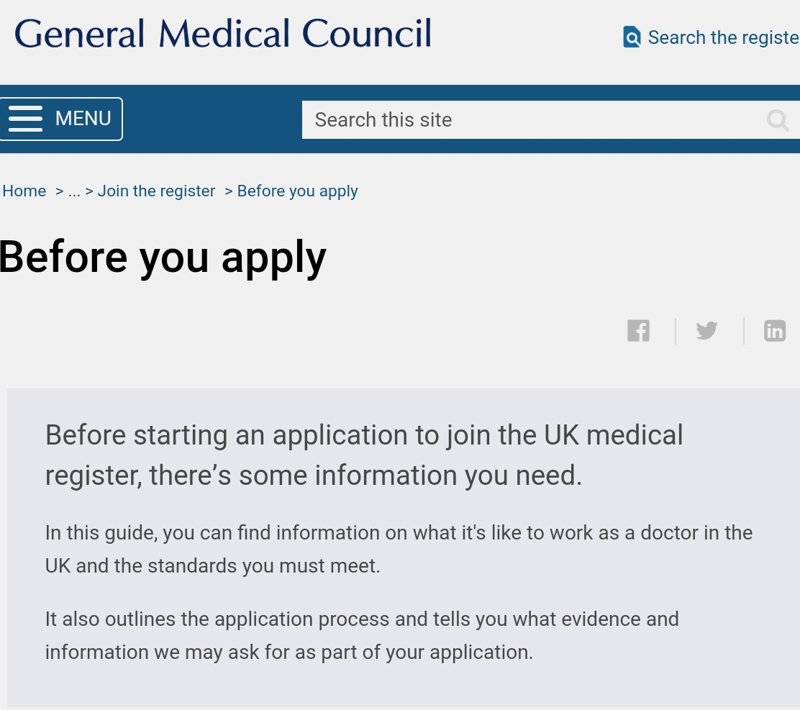

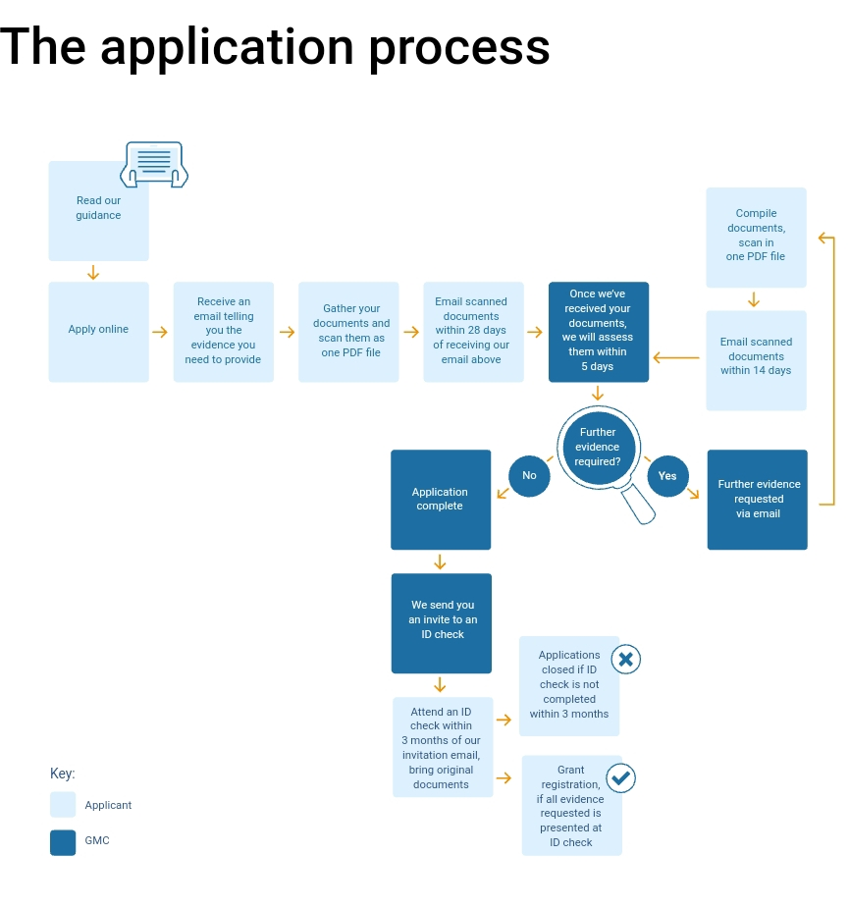

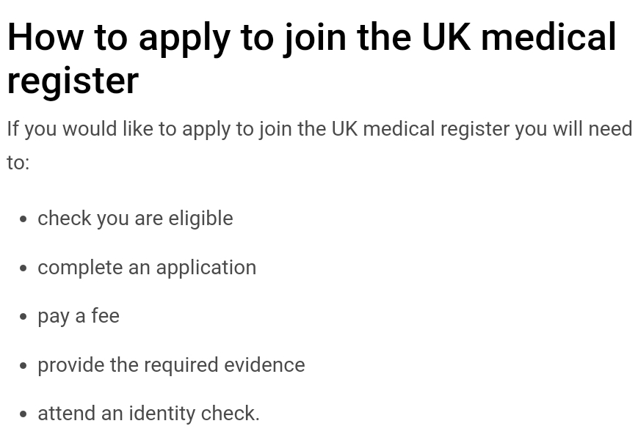

* You need to consider what roles you're looking for, do your research and have an idea of the kinds of roles that are available, these website have information on the jobs available:

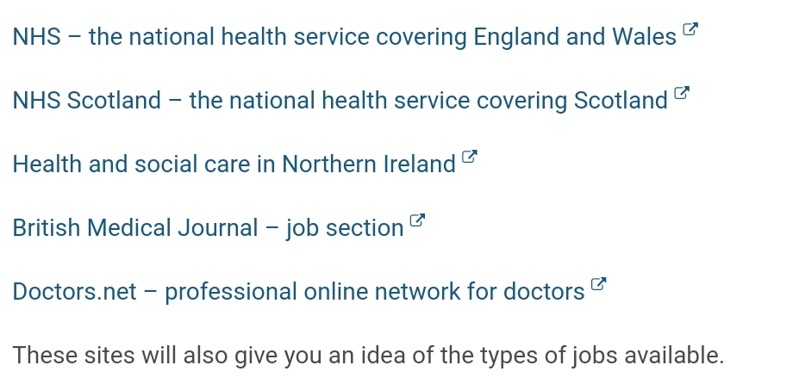

* You need to understand the deanery system and the hospitals located in them:
  + Check out the British Medical Association Website: <https://www.bma.org.uk/advice/career/applying-for-training/find-your-deanery>
* Be aware of the upcoming changes that are coming. By 2022 some of the assessment criteria will change, you need to be aware of these changes and apply accordingly.

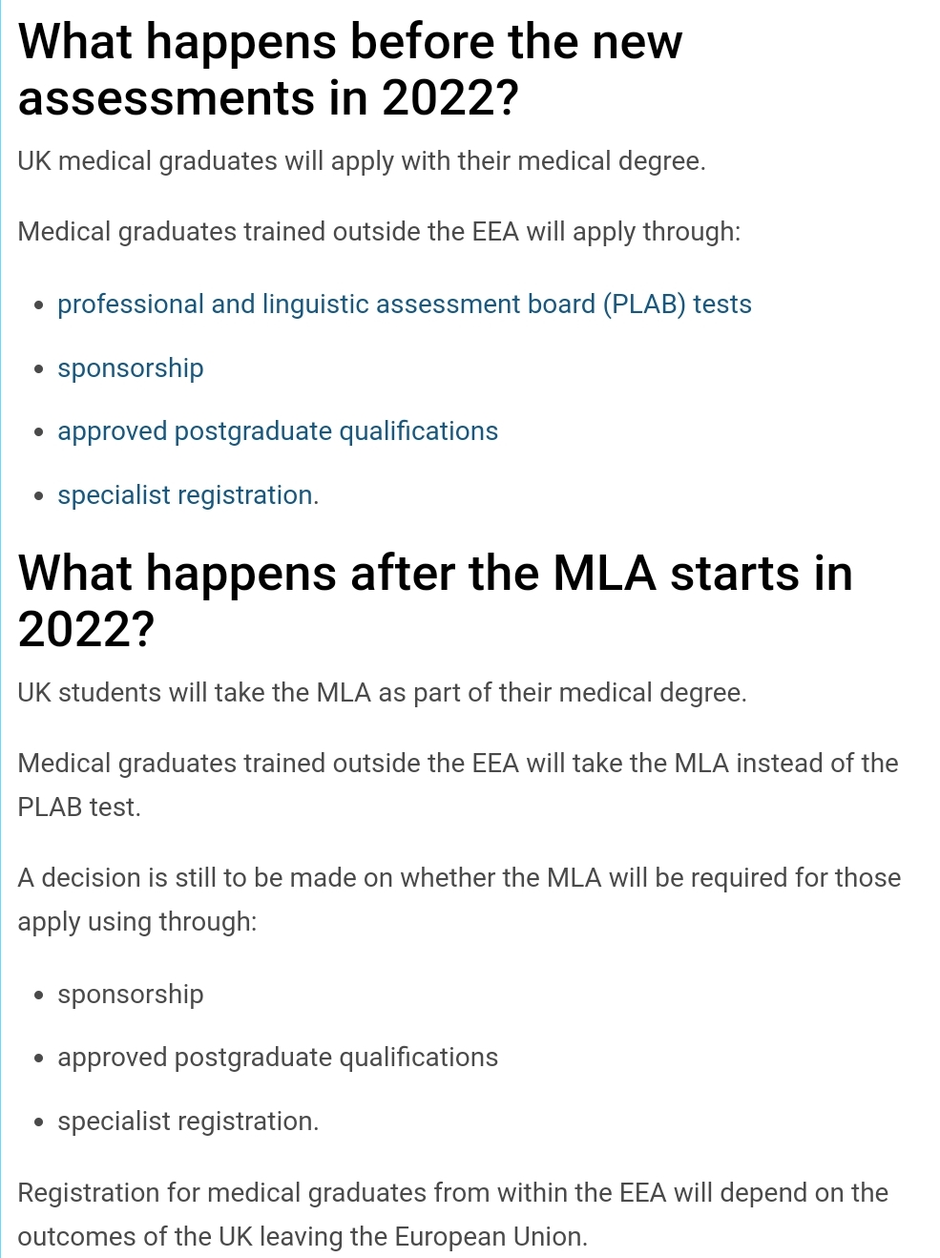

* Medical licensing Assessment does not apply to students coming from the EEA, are currently not being assessed as per EU agreements.
* For any further questions you can email the council; [mla@gmc-uk.org](mailto:mla@gmc-uk.org)
* Now it is time to consider the what kind of licensing you need, there are several types of registration that are available on way to asses which type is via the assessment tool found on the GMC website.
* <https://www.gmc-uk.org/registration-and-licensing/join-the-register/registration-applications/application-registration>

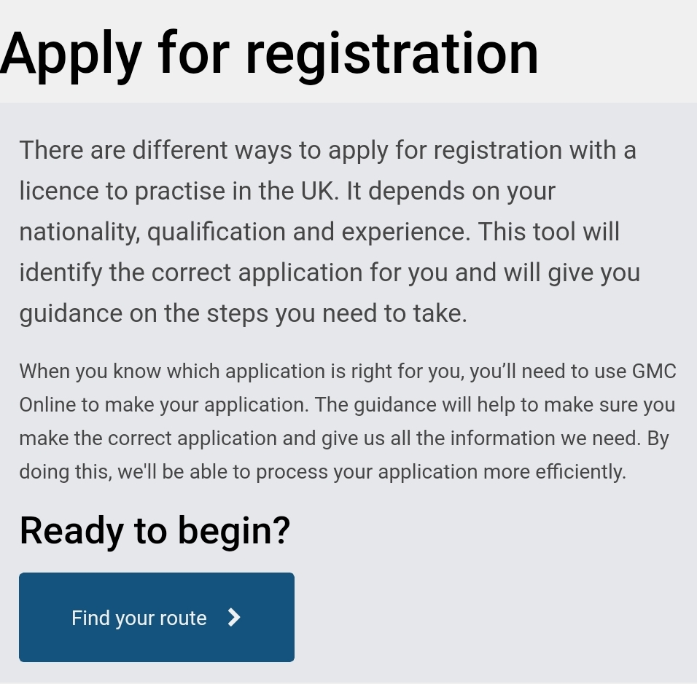

* Download a copy of “Good medical practice” to give you an idea of what NHS hospitals are looking for when hiring F1's.

<https://www.gmc-uk.org/-/media/documents/good-medical-practice---english-1215_pdf-51527435.pdf>

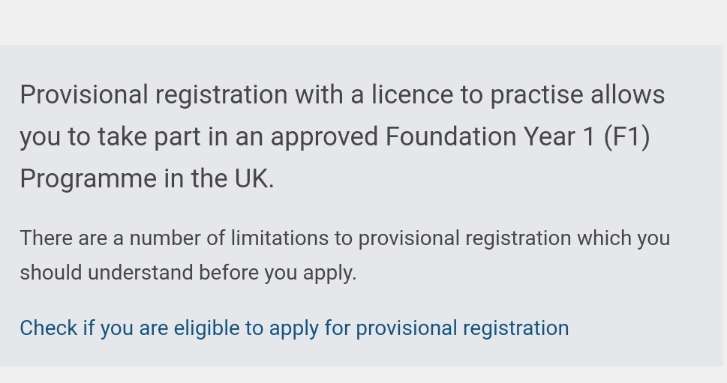

* After the successful completion your F1 programme you have the ability to apply for the full registration.

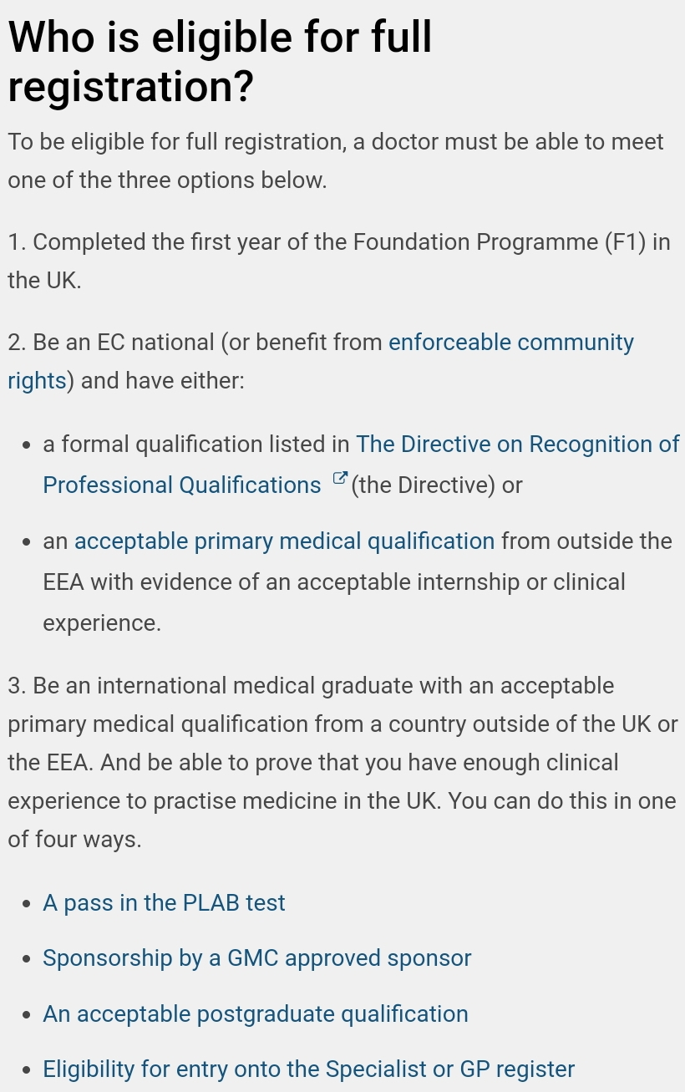

* Evidence to support your application:
  + All applicants are required to provide evidence of your English language skills. Such as the PLAB tests and IELTS.
  + Evidence of your fitness to practise: further information is here <https://www.gmc-uk.org/registration-and-licensing/join-the-register/before-you-apply/guide-on-completing-the-declaration-of-fitness-to-practise>
  + Acceptable primary medical qualification: <https://www.gmc-uk.org/registration-and-licensing/join-the-register/eea-countries/Poland> 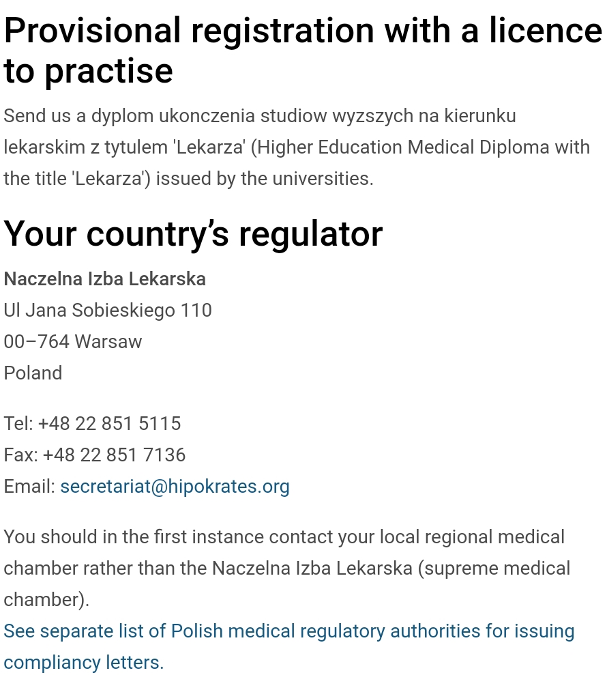
  + For those who are nationals of a country outside the UK, EEA (European Economic area) or Switzerland need to have their qualification verified by the ECFMG via the online system. <https://www.ecfmgepic.org/index.html> , <https://www.ecfmg.org> 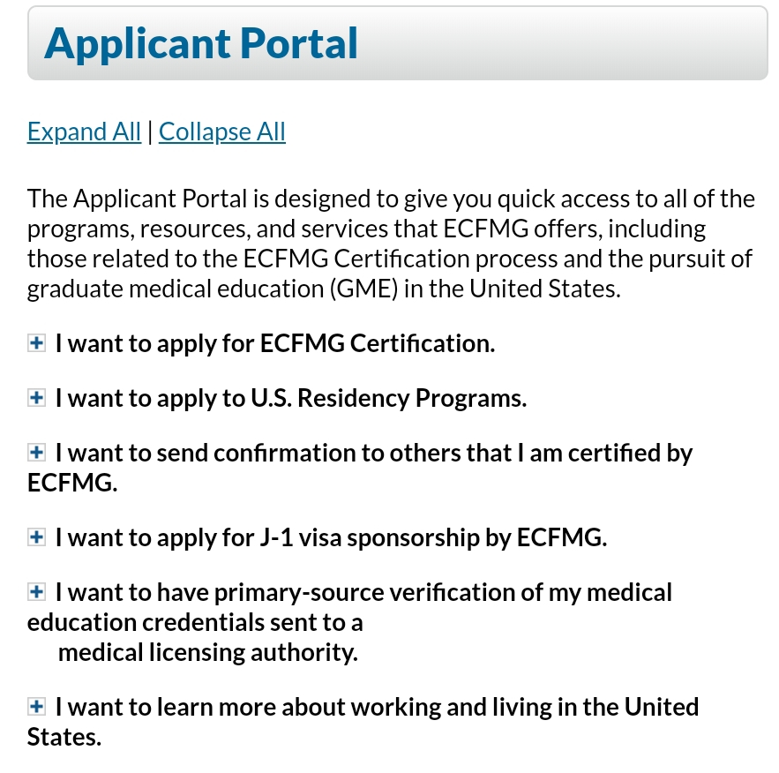
  + 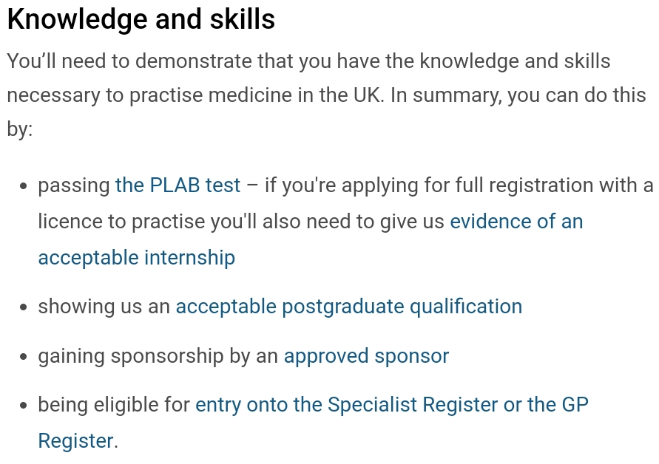

**Canada**:

Resources:

<https://www.carms.ca/>

<https://www.carms.ca/match/r-1-main-residency-match/>

<http://www.carms.ca/match/r-1-main-residency-match/eligibility-criteria/>

<https://www.mccevolution.ca/international-students-graduates/assessment-overview/>

<https://mcc.ca/examinations/>

Overview

The licensing exams are managed by the Medical Council of Canada (MCC). The match process is regulated by the Canadian Resident Match Service (CaRMS). To apply for the CaRMS match, **which begins in August**, you must fulfil the first set of criteria below. Each province may have additional requirements so make sure you are aware of these well before applying!

Criteria for applying to the CaRMS Match:

1. Must be a **Canadian citizen** or have a **Canadian permanent resident card**.
2. Exams (for 2018 applications)
   1. Medical Council of Canada Evaluating Examination (MCCEE) (phased out after 2018)
   2. Medical Council of Canada’s Qualifying Examination (MCCQE) Part I (Part II is written in the early residency years)
      1. This is written within 15 months of graduating
   3. National Assessment Collaboration (NAC)
      1. Must write after the MCCEE
      2. Must be completed by the same September in which you want to participate in the match process
3. Exams (for 2019 and later applications)
   1. Medical Council of Canada’s Qualifying Examination (MCCQE) Part I (Part II is written in the early residency years)
      1. This is written within 15 months of graduating
   2. National Assessment Collaboration (NAC)
      1. Must be completed by the same September in which you want to participate in the match process

Visit the following CaRMS page for province-specific criteria: <https://www.carms.ca/match/r-1-main-residency-match/eligibility-criteria/summary-intake-criteria-international-medical-graduates-imgs-province/>

Programs available:

<https://www.carms.ca/match/r-1-main-residency-match/program-descriptions/>

Timeline:

Here is a link to a timeline for the 2018 residency applications (i.e. applying in 2018 and starting residency in 2019): <https://www.carms.ca/match/r-1-main-residency-match/r-1-match-timeline/>

September 5 - start application on CaRMS

October 11 - select program

November 8 - CaRMS recommends you share examinations and documents by this date

November 16 - CaRMS recommends having hard copy reference letters arrive by this date

November 20 - assign applications and required documents to programs

November 20 - file review begins

November 27 - deadline to assign letters of references

January 24 - ranking period begins

-- Interview with programs --

February 13 - submission of rank list

February 26 - match results for first iteration are available through CaRMS online

Note: Here you can see that **it is important to be in group B for 4th year as a Canadian in order to make it to in--person interviews** usually happening in the month of January to beginning of Feb

Fees:

MCCEE: $1,820

MCCQE Part I: $1,230

NAC: $2,775

CaRMS fee: <https://www.carms.ca/match/r-1-main-residency-match/match-fees-r1/>

Some practical advice:

**How to strengthen CaRMS application:**- Complete an elective with the program you are interested in.  
- During these electives, try your absolute best to make a good impression by working well with fellow students, attendings, nurses, and other members of the support team at the wards. Subsequently, you may be able to attain a reference letter from the attending supervising you.

- Proposed timeline → These electives begin at the end of 3rd year around May 2020, the more electives you pursue, the more letters you can get from attendings...the better! Electives will end around September 2020 → The reference letters need to be gathered by November 2020 of 4th year at the CaRMS application portal.

- Overall, Canada doesn’t rely too much on numbers as they use parameters like Multiple Mini Interviews and CASPER to assess the suitability of the applicant. They look at personality traits and how well you work with others, described in your reference letters as strong predictors of your success in residency.

- Step 1 is not required in the Canadian residency applications, therefore there’s overall a lack of systematic objectivity in the application process so clearly it is very important to attend as much electives back home as possible so they get to know YOU!! Some programs even recommend that you complete an on-site elective in their program if you’re even thinking of applying while others don’t. Taking into account elective significance, and without an initial filter like Step 1...then it all can really become subjective.

- More information on NAC OSCE and MCCQE1 -- Coming soon.

**How to apply for electives**

- Instructions on application process and elective opportunities available can be found here: <https://www.afmcstudentportal.ca/>

- You need to make an account and it costs about $700 for registration.

- DEADLINES ARE SUPER IMPORTANT. Some elective opportunities open applications 6 months before. It operates on first come per serve and can become a lottery process. Some priorities are given to residents of specific provinces. For example, Ob/gyn in Manitoba—notice that for IMGs, they only let Manitoba resident--IMG do an elective on their site. So overall setting aside other aspects, with all the other eager IMGs applying for electives→ you need to be on top of your game, plan WAY AHEAD of time, sit by your computer for when that clock strikes and apps are open: you should have your documents ready and all you have to do is press submit.

- REMEMBER -- the elective opportunities available to you should be under “Canadians studying abroad” only.

**Summary**

1) Be in **group A in 3rd year → finish 3rd year early, so you can do a ton of electives beginning in May 2020 and impress whoever you breathe same air with at the Canadian hospitals**

2) Be in **group B in 4th year → make it to your in-person interviews in January/February 2021**.There’s less chances of getting ranked highly by program directors, if you do not attend in-person interviews/pre-interview events. As said Canada is known for holding unique interviews (looking at your non-verbal communication, actors interview stations, etc).

NASG—CaRMS presentation: ________ (looking for link—coming soon).

**Australia**:

* Medical Board of Australia has presented all the information required to better understand the process of applying. <https://www.medicalboard.gov.au/registration/international-medical-graduates.aspx>
* <http://www.amc.org.au/assessment/list-of-medical-schools>
* There are three main assessment pathways for us IMG’s
  + Competent Authority Pathway
  + Standard Pathway (this is what will apply to most of us)
  + Specialist Pathway
* Standard Pathway: <https://www.medicalboard.gov.au/Registration/International-Medical-Graduates/Standard-Pathway.aspx>

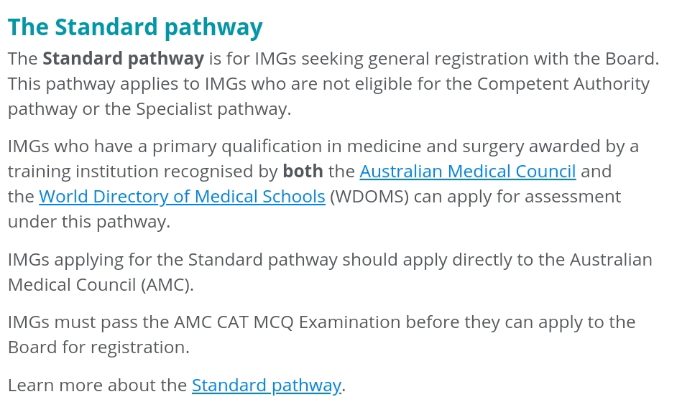

* Link to a PDF on self assessment to help you determine which pathway you need to take: <https://www.medicalboard.gov.au/documents/default.aspx?record=WD14%2f14120&dbid=AP&chksum=UwTVUB0ErD5lugUQLSf3FA%3d%3D>
* An overview of pathways to registration for IMG's wishing to proactive medicine in Australia.

<https://www.medicalboard.gov.au/documents/default.aspx?record=WD14%2f14124&dbid=AP&chksum=OWt%2f6miTwtRJEMYTj9Sm3g%3d%3d>

* 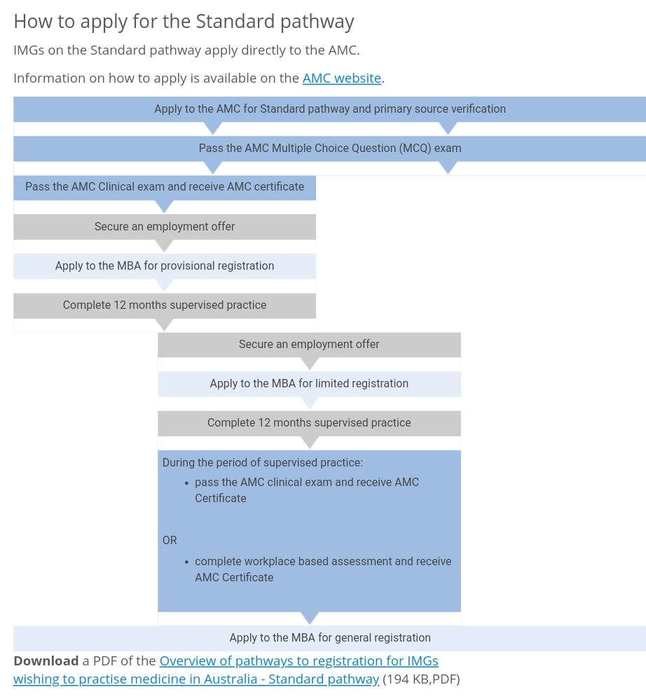
* 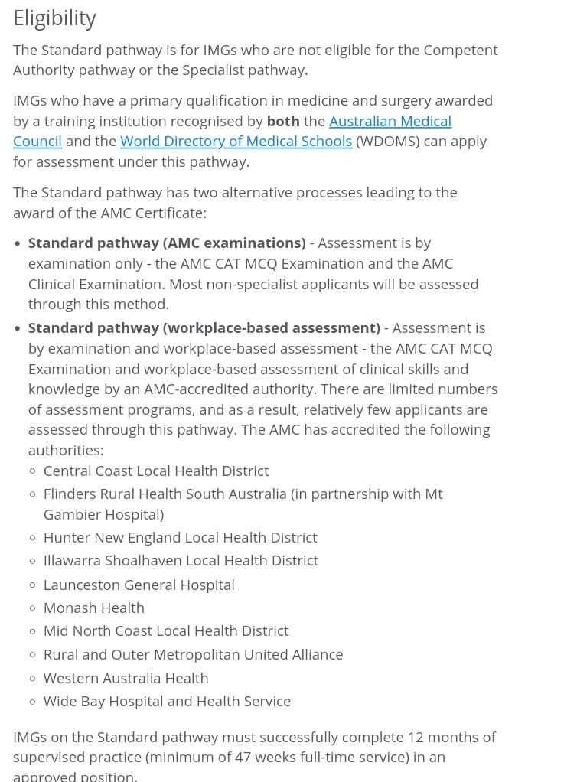
* 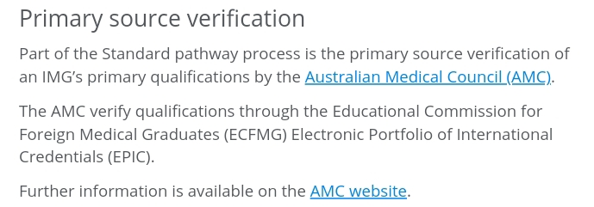
* All IMG's looking to go through the standard pathway must pass the Australian

Medical Council CAT MCQ examination before applying to the AMB for registration

* The registration is called Limited registration due to requirements of supervision for 12 months whilst training within the Australian medical system.
* After the successful completion you become eligible to apply for general registration <http://www.medicalboard.gov.au/Registration-Standards.aspx>
* <https://www.medicalboard.gov.au/documents/default.aspx?record=WD18%2f24901&dbid=AP&chksum=m7Wy3lneNVV40o5RtYH%2bzw%3d%3D>